Trends Analysis and Forecasting

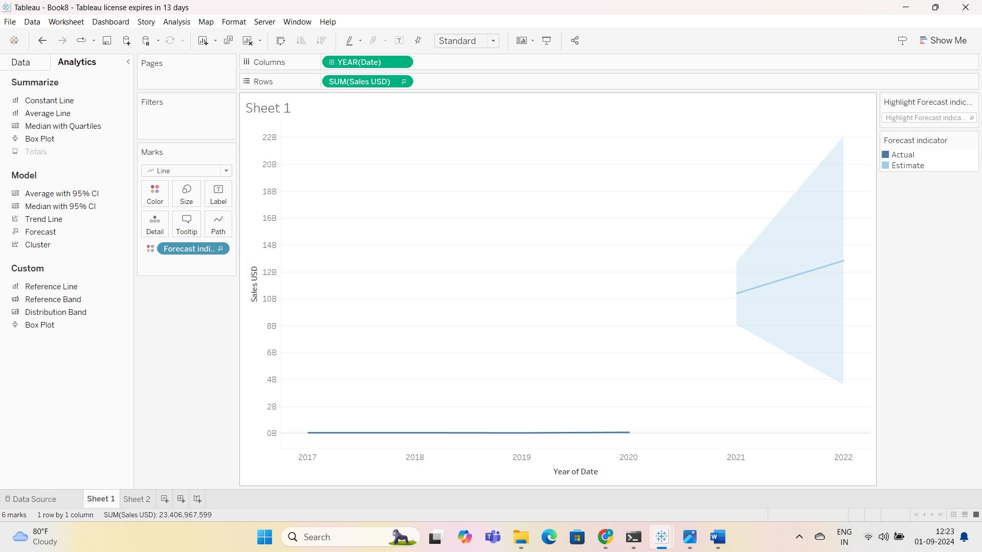

**Describe Data Collection**:

* Explain where and how you got the data (e.g., websites, APIs).
* Mention the type of data (e.g., transaction data, prices) and the time period.

**Analyze Key Trends**:

* Identify trends in the NFT market (e.g., sales volume, price changes).
* Use charts or graphs to show these trends.
* Write a brief summary of what the trends mean.

**Explain Forecasting Models**:

* Describe the forecasting models used (e.g., ARIMA, LSTM).
* Explain why these models were chosen and their purpose.
* Evaluate model performance using metrics (e.g., MAE, RMSE).

**Include Source Code**:

* Provide code for data collection, analysis, and forecasting.
* Comment on the code for clarity.

**Benefits for the NFT Ecosystem**

1. **Artists**:
   * **Market Trends**: Identify popular NFT types to align content with demand.
   * **Pricing**: Use pricing trends to set competitive prices.
   * **Audience**: Target the right audience based on buyer data.
2. **Collectors**:
   * **Valuation**: Find NFTs appreciating in value.
   * **Market Sentiment**: Understand which NFTs are gaining or losing popularity.
   * **Timing**: Determine the best times to buy or sell.
3. **Investors**:
   * **Opportunities**: Spot high-growth areas for investment.
   * **Risk**: Assess market volatility and investment risks.
   * **Diversification**: Explore various NFT categories for a balanced portfolio.

These insights help artists, collectors, and investors make informed decisions and optimize their actions in the NFT market.